Using the MVC

The controller is what interacts with the model. This is where we start doing things like $article=App\Article::create, or $article=App\Article::all();

Note, instead of going App\Article all the time, we know the class is called article, we can call it by just that if we import the file at the top of the controller:

Use App\Article;

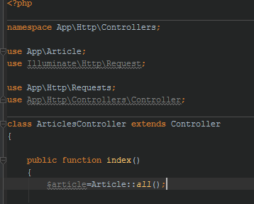

We can then pass this $article object on to a view.

The article object takes the ‘shape’ of whatever it’s assigned to. In the above example it’s assigned to Article::all, and thus it takes the form of an array of objects.

If you specify a single article via: Article::find(2) it will take the form of a regular array.

The views are basic HTML/PHP sections.

Use blade templating to insert the value of $article (which pulls from the database).

Transfer an entire article collection (set of articles) to it and then use @foreach (article as articles) …eg for each object as class, do X, to cycle through and display. You can even filter through in the controller to create a smaller array before passing it through.

The routing basically defines which URLs lead where. You can use wildcards: {wildcard} in the uRL and it will take the shape of anything you pass to it. This wildcard is then passed on as an argument to the respective method in the controller:



